

UNLEASHING THE POTENTIAL OF

OUR YOUTH: A STUDENT

PERFORMANCE ANALYSIS

# PROJECT REPORT

***Submitted By***

|  |  |
| --- | --- |
| SATHIYA RUBHA M | 611220104134 |
| SURYAPRABA V | 611220104159 |
| TAMIZHARASAN K | 611220104161 |
| VENKATAGIRIRAJU U | 611220104318 |

***in partial fulfillment for the award of the degree***

***of***

**BACHELOR OF ENGINEERING**

***in***

# COMPUTER SCIENCE AND ENGINEERING

**KNOWLEDGE INSTITUTE OF TECHNOLOGY**

# SALEM-637504

# ANNA UNIVERSITY :: CHENNAI-600025

# OCT-2023

# ACKNOWLEDGEMENT

At the outset, we express our heartfelt gratitude to **GOD,** who has been our strength to bring this project to light.

At this pleasing moment of having successfully completed our project, we wish to convey our sincere thanks and gratitude to our beloved president **Mr. C. Balakrishnan,** who has provided all the facilities to us.

We would like to convey our sincere thanks to our beloved Principal **Dr. PSS. Srinivasan,** for forwarding us to do our project and offering adequate duration in completing our project.

We express our sincere thanks to our Head of the Department **Dr. V. Kumar,** Department of Computer Science and Engineering for fostering the excellent academic climate in the Department.

We express our pronounced sense of thanks with deepest respect and gratitude to our SPOC **Mr. T. Karthikeyan,** Assistant Professor Computer Science and Engineering Department, for his valuable and precious guidance and for having amicable relation.

With deep sense of gratitude, we extend our earnest and sincere thanks to our Faculty Mentor **Mrs. M. Gopikumaran,** Assistant Professor, Department of Computer Science and Business System for their guidance and encouragement during this project.

We would also like express our thanks to all the faculty members of our department, friends and students who helped us directly and indirectly in all aspects of the project work to get completed successfully.

**BONAFIDE CERTIFICATE**

Certified that this project report titled **“UNLEASHING THE POWER OF OUR YOUTH: A STUDENT PERFORMANCE ANALYSIS”** is the bonafide work of **“SATHIYA RUBHA M (611220104134), SURYAPRABA V (611220104159), TAMIZHARASAN K (611220104161), VENKATAGIRIRAJU U (611220104318),”**

who carried out the project work under my supervision.

# SIGNATURE SIGNATURE

Dr. V. KUMAR M.E., Ph.D., Mr. M. Gopi Kumar

# HEAD OF THE DEPARTMENT FACULTY MENTOR PROFESSOR ASSISTANT PROFESSOR

Department of Computer Science Department of Computer Science and Engineering, and Engineering,

Knowledge Institute of Technology, Knowledge Institute of Technology, Kakapalayam, Kakapalayam,

Salem- 637 504. Salem- 637 504.

**SPOC HEAD OF THE DEPARTMENT**

**TABLE OF CONTENTS**

|  |  |  |
| --- | --- | --- |
| **CHAPTER NO** | **TITLE** | **PAGE NO** |
| **1** | **INTRODUCTION** | 1 |
|  | 1.1 PROJECT OVERVIEW | 1 |
|  | 1.2 PURPOSE | 1 |
| **2** | **LITERATURE SURVEY** | 3 |
|  | 2.1 REFERENCES (SURVEY CONTENT) | 3 |
|  | 2.2 PROBLEM DEFINITION STATEMENT | 8 |
| **3** | **IDEATION & PROPOSED SOLUTION** | 10 |
|  | 3.1 EMPATHY MAP CANVAS | 10 |
|  | 3.2 IDEATION & BRAINSTORMING | 12 |
|  | 3.3 PROPOSED SOLUTION | 16 |
|  | 3.4 PROBLEM SOLUTION FIT | 18 |
| **4** | **REQUIREMENTS ANALYSIS** | 19 |
|  | 4.1 FUNCTIONAL REQUIREMENT | 19 |
|  | 4.2 NON - FUNCTIONAL REQUIREMENT | 20 |

|  |  |  |
| --- | --- | --- |
| **5** | **PROJECT DESIGN** | 21 |
|  | 5.1 DATA FLOW DIAGRAMS | 21 |
|  | 5.2 SOLUTION & TECHNICAL ARCHITECTURE | 22 |
|  | 5.3 USER STORIES | 25 |
| **6** | **CODING & SOLUTIONING** | 28 |
| **7** | **RESULTS** | 34 |
|  | 7.1 PERFORMANCE METRICS | 34 |
| **8** | **ADVANTAGES & DISADVANTANGES** | 37 |
| **9** | **CONCLUSION** | 37 |
| **10** | **FUTURE SCOPE** | 38 |
| **11** | **APPENDIX** | 39 |
|  | 11.1 SOURCE CODE | 39 |
|  | 11.2 SCREENSHOTS | 45 |
|  | **GITHUB &PROJECT VIDEO DEMO LINK** | 52 |
|  | **REFERENCES** | 53 |

# CHAPTER-1

# INTRODUCTION

## 1.1 PROJECT OVERVIEW

## The "Student Performance Analysis and Improvement Recommendations" project aims to use IBM Cognos to collect and analyze data on the academic performance of students at individual, class, or school levels. The project uses various data sources, including grades, test scores, attendance records, and surveys, to identify areas of strength and weakness in academic performance and factors contributing to student success or challenges. By analyzing the data with IBM Cognos, the project provides tailored instruction and intervention recommendations to improve academic performance. The expected outcomes include insights into how students are performing academically, identification of areas of strength and weakness, and recommendations for improvement. Overall, the project emphasizes the importance of student performance analysis as a critical component of improving academic performance, using IBM Cognos as a powerful tool to achieve these goals. Over all, the project highlights the importance of data-driven analysis for improving academic performance.

## 1.2 PURPOSE

A country's growth is strongly measured by quality of its education system. Education sector, across the globe has witnessed sea change in its functioning. Today it is recognized as an industry and like any other industry it is facing challenges, the major challenges of higher education being decrease in students' success rate and their leaving a course without completion. Analyzing student work is an essential part of teaching. Teachers assign, collect and examine student work all the time to assess student learning and to revise and improve teaching. Ongoing assessment of student learning allows teachers to engage in continuous quality improvement of their courses. Many factors can influence a student's performance, including the influence of the parents' educational background, test preparation and so on. The dataset contains the marks secured by 1000 students from a school. This project analyses and correlates student performance with different attributes. The analysis aims to understand the influence of important factors such as parental level of education, the status of test preparation course etc. on the performance of the students in the exam.

# 

# CHAPTER-2

# LITERATURE SURVEY

**2.1. STUDENT PERFORMANCE ANALYSIS SYSTEM**

**Authors:** Somya Mishra, Mrunal Lokare, Aniket Patil, Prof. Chandrashekhar Badgujar

**Year of Publication:** 04 Apr 2021

This paper reviews online interface for students, faculty, etc. to increase efficiency of record management, reduce access and delivery time, enhance system security, and minimize non-value-added tasks. The web-based student performance analysis system offers benefits such as time and effort-saving, efficient analysis, accuracy, easy data management, customization, scalability, enhanced decision-making, and improved communication to educational institutes and coaching classes. Drawbacks of implementing a web-based student performance analysis system include dependence on technology, setup and maintenance efforts, learning curve, data security concerns, customization limitations, accessibility/ connectivity issues, and overreliance on automated analysis.

**2.2. STUDENT PERFORMANCE ANALYSIS SYSTEM USING DATA MINING**

**Authors:** Disha Kalambe, Anita Labade, Surabhi Khedekar, Komal Mahajan

**Year of Publication:** 24 Apr 2020

The proposed system uses data mining to analyze student performance in academic performance, extra-curricular activities, strengths, weaknesses, and hobbies. It generates a scorecard and provides guidance for improvement, contributing to overall growth. The proposed system has the potential to harness the power of data mining to analyze student performance from a holistic perspective and provide personalized guidance, leading to improved educational outcomes for students. The system has drawbacks such as data quality and accuracy, lack of contextual understanding, algorithm bias, limited human interaction, implementation challenges, privacy and security risks.

**2.3. STUDENTS’ PERFORMANCE ANALYSIS USING MACHINE LEARNING ALGORITHMS**

**Authors:** Rosemary Vargheese, Adlene Peraira, Aswathy Ashok and Bassant

Johnson

**Year of Publication:** 29 June 2022

Universities and organizations struggle with analyzing diverse student performance 3

data. SPAS, a proposed system, uses data mining to predict performance and aid lecturers in identifying struggling students. Universities and organizations struggle with analyzing diverse student performance data. SPAS, a proposed system, uses data mining to predict performance and aid lecturers in identifying struggling students. System limitations were identified considering the users’ evaluations on the system, which are resources, time constraint, inflexible rules implemented in the system, the prediction is not updated dynamically within the system’s source codes.

**2.4. STUDENT PERFORMANCE ANALYSIS SYSTEM (SPAS)**

**Authors:** Chew Li Sa, Dayang Hananibt. Abang Ibrahim, Emmy Dahliana Hossain, Mohammad bin Hossin

**Year of Publication:** Jan 2021

SPAS is a new system that tracks and analyzes student performance in a specific course at FCSIT, UNIMAS. It utilizes predictive system based on classification data mining to generate performance prediction rules, addressing restricted access to the existing student management system for Information System department lecturers. The proposed system has recognition of the need for a system to track students' performance, proposal of a predictive system, focus on a specific course and department, mention of data mining technique, emphasis on student performance improvement. The system has drawbacks of lack of details on the student management system, limited explanation of privacy setting, limited scope of the proposed system, limited details on data mining technique, absence of potential challenges or limitations.

**2.5. STUDENTS PERFORMANCE ANALYSIS SYSTEM**

**Authors:** Vinay Devabhaktuni, Kancharla Sharath Reddy, V. Shiva Teja, G. Kavitha Reddy

**Year of Publication:** 06 June 2022

SPAS bridges gap between employers and future IT employees by analyzing college level student performance. It uses intelligent learning algorithm for prediction Traditional techniques inadequate, need tool for extracting useful information. Pros of SPAS and tool for extracting useful information from student performance data bridges gap between employers and students with insights on skills' readiness for job placement. Utilizes intelligent learning algorithm and rich database for accurate performance prediction. Employee cumulative predictor algorithm with random forest trees for robust and reliable model. Facilitates data-driven decisions for universities by extracting insights from various student performance data formats. Overcomes challenges of analyzing increasing student data, enabling informed decisions about performance and placement. Cons of this system is automation may lead to job displacement, causing concerns about unemployment and career prospects. 4 Difficulty in attaining necessary skills for desired IT jobs may indicate a gap in the education system, resulting in inequality and limited opportunities. Reliance on SPAS for performance evaluation may raise data privacy and security concerns. The cumulative predictor algorithm in SPAS may have limitations in accuracy and reliability. Extracting useful information from various formats of student data may pose challenges in data extraction, quality, and integration. Concerns may arise regarding the potential impact,

reliability, and privacy of using SPAS for performance evaluation and prediction.

**2.6. STUDENTS PERFORMANCE ANALYSIS SYSTEM USING CUMULATIVE PREDICTOR ALGORITHM**

**Authors:** Mr. K. Praveen Kumar, K. Sai Pranav, D Gowtham, S. Abhishek

**Year of Publication:** 22 May 2022

The project highlights the increasing automation of mundane tasks and rising expectations for students with programming skills, and the aim of the project to bridge the gap between employers and future employees using a college-level Student Performance Analysis System (SPAS). SPAS features an online web application system, intelligent learning algorithm, and cumulative predictor algorithm for performance evaluation. The objective is to provide an overview of the project's focus on using SPAS for analyzing student performance data and making job placement predictions. The implementation of SPAS at the college level can provide several benefits, including bridging the skills gap, automating mundane tasks, utilizing intelligent learning algorithms, data-driven decision making, improving employability, and enhancing student engagement. SPAS has potential benefits in bridging the employer-employee gap, but limitations such as limited data availability, biased data, reliance on historical data, lack of holistic evaluation overemphasis on placement outcomes, potential stress and pressure on students, and technical challenges must be carefully considered for effective and ethical use in the college setting.

**2.7. STUDENT PERFORMANCE ANALYSIS SYSTEM**

**Authors:** Devita Durge, Nikhil Bagul, Rushikesh Gadge, Siddhesh Bhavsar

**Year of Publication:** Sep 2020

The aims and objective of the project that is to allow users (faculty) to analyze progress of his subject, allow students to compare his performance in different tests. Provide convenience to faculty to guide and mentor students in their academic performance. To

design a user-friendly graphical user interface. To conveniently maintain digital records of student, faculty and courses. This system has the benefits of User-friendly GUI for faculty to manage student data and for students to view academic records. 5 Academic records and performance analysis stored in image format. Pie chart displays enrolments in each course. Machine learning regression algorithm predicts upcoming test marks. Easy data update and maintenance in digital format. No data loss threat with multiple data copies. The system has the drawbacks of Single student cannot enroll for multiple courses using same student id. Graphical user interface is user friendly but not fascinating. Student cannot analyze his grip over subtopics of same subject.

**2.8. ACADEMIC PERFORMANCE ANALYSIS**

**Authors:** Mr. M. Thirunavukkarasu, B.J.S.S Sriram, Javvaji Chandrasekhar Reddy

**Year of Publication:** Apr 2021

The main objective of this system is analyzing students' overall academic performance using data segregation and prediction techniques. System provides access for students to view results and professors to receive pass/fail prediction reports using machine learning (Linear Regression, SVM). Enhances academic performance evaluation and support by assisting students who may need additional help. Focuses on analyzing overall academic performance, not just external exams. Utilizes data segregation and prediction techniques to predict pass/fail for students. Provides a system for students to access their results and for professors to receive reports. Helps professors assist students who may need additional support. Enhances academic performance evaluation and support through machine learning algorithms. Improves student performance and increases chances of passing exams. Some potential cons in this system is data accuracy and reliability, overreliance on previous results, limited scope of prediction, ethical concerns, lack of personalized approach.

**2.2 PROBLEM DEFINITION STATEMENT**

**CUSTOMER PROBLEM STATEMENT:**

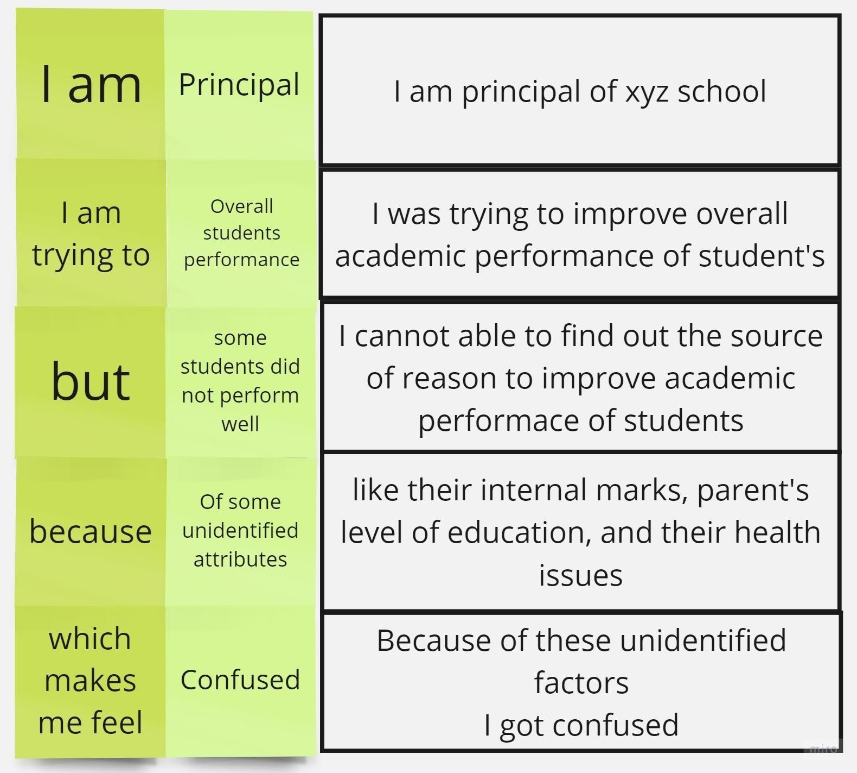

I am the principal of xyz school. I was trying to improve the overall academic

performance of students. But some of the students did not perform well because of various factors like their internal marks, parent’s level of education, and health problems because of their food habits which they intake. So, I got confused, so I need to analyze these attributes for each student and identify the source of problem and improve their performance.

**Solution Statement**

|  |  |  |  |  |  |
| --- | --- | --- | --- | --- | --- |
| **Problem Statement (PS)** | **I am (principal)** | **I’m trying to** | **But** | **Because** | **Which makes me feel** |
| PS-1 | principal | Improve the | Some | Of the food | sad |
|  |  | wellness of the student | Students  have health issues | they eat |  |
| PS-2 | principal | Improve | They did | They did not | angry |
|  |  | performance | not | spend their |  |
|  |  | on internal | perform | own time to |  |
|  |  | tests | well in | study at their |  |
|  |  |  | internal | home |  |
|  |  |  | exams |  |  |
|  |  |  |  |  |  |

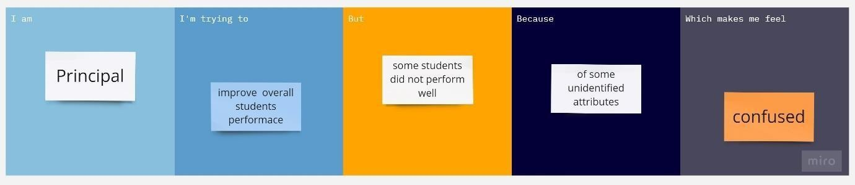

# CHAPTER-3

# IDEATION & PROPOSED SOLUTION

## 3.1 EMPATHY MAP CANVAS STEPS FOLLOWED

1. Start by creating a new mural and selecting the "Empathy Map" template from the template library.

2. Divide the map into four quadrants labeled "Say," "Do," "Think," and "Feel."

3. In the center of the map, write the name of the persona you are creating the empathy map For. This could be a student, teacher, or administrator involved in the project.

4. Begin by filling in the "Say" quadrant with statements or quotes that the person might say related to the project. This could include things like "I'm struggling with understanding the material" or "I need more individualized attention from my teacher."

5. Move on to the "Do" quadrant and fill it with actions or behaviors that the persona might engage in related to the project. This could include things like attending after-school tutoring sessions or completing extra practice exercises.

6. Fill in the "Think" quadrant with thoughts or beliefs that the persona might have related to the project. This could include things like "I don't think I'm smart enough to succeed" or "I believe that hard work pays off."

7. Finally, fill in the "Feel" quadrant with emotions or feelings that the person might have related to the project. This could include things like feeling frustrated or overwhelmed, or feeling proud and accomplished when they succeed.

**Empathy Map of Students Performance Analysis**

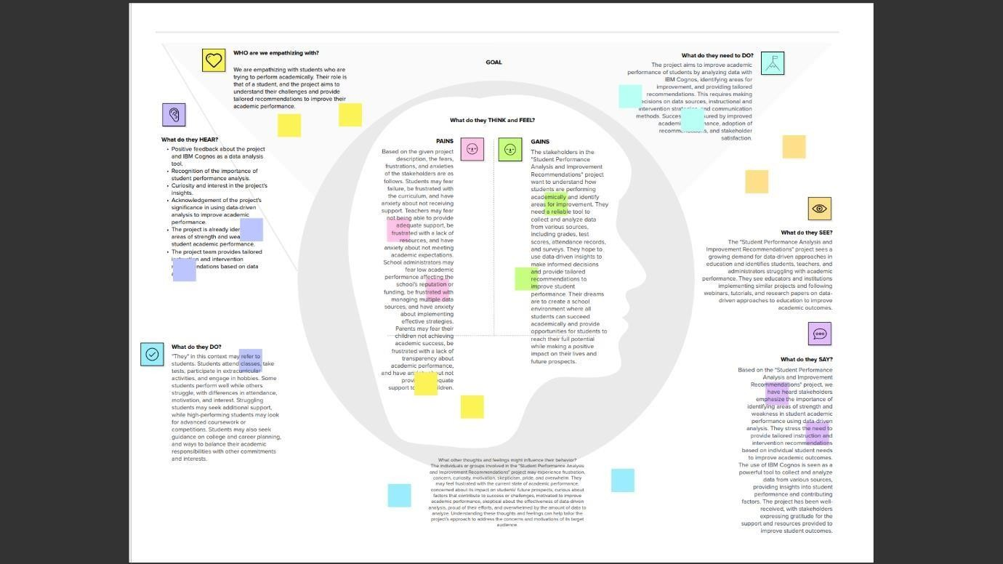

## 3.2 BRAIN STORMING AND IDEA PRIORITIZATION

# Team Gathering, Collaboration and Select the Problem Statement

# 

**Brainstorm, Ideas Listing and Grouping**

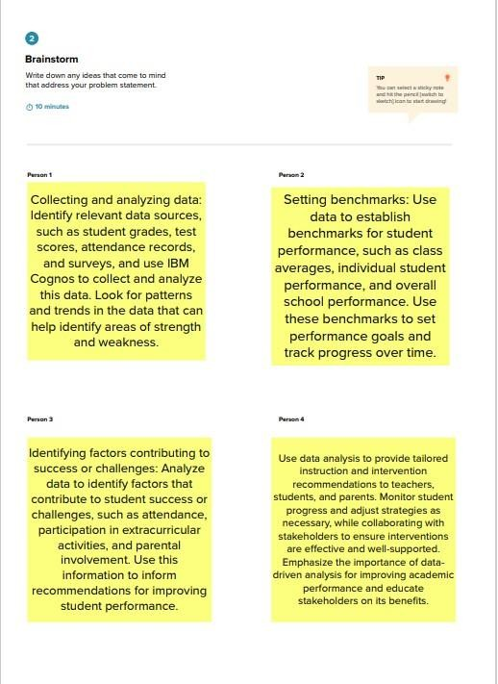

**Group Ideas**

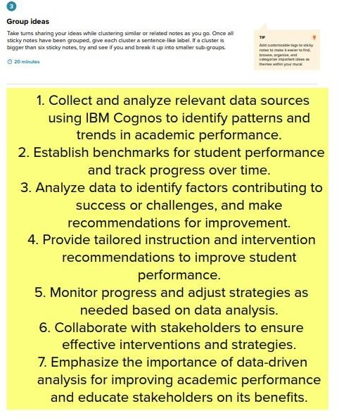

**Prioritization**

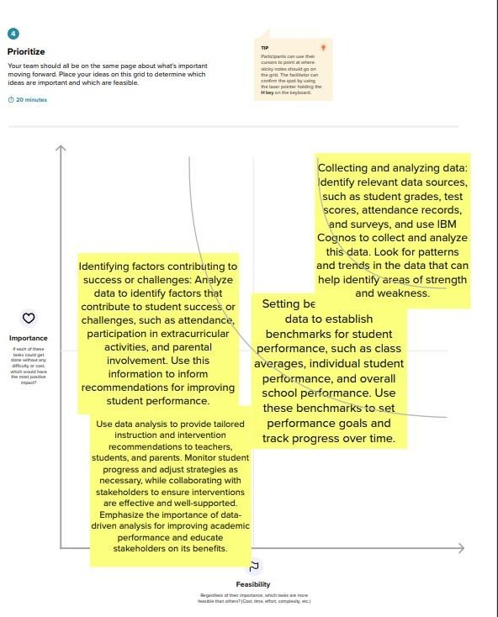

# 3.3 PROPOSED SOLUTION

|  |  |  |
| --- | --- | --- |
| **S. No** | **Parameter** | **Description** |
| 1. | Problem Statement (Problem to be solved) | “Student performance analysis and improvement recommendations” project is to improve academic performance by analyzing and  identifying areas of strength and weakness for student’s classes and schools, this project emphasizes the importance of data driven analysis to identify factors contributing to student success or challenges and to provide recommendations for  improvement. |
| 2. | Idea / Solution description | Collect and analyze relevant data sources using IBM Cognos to track the progress and identify factors  contributing to success or challenges and visualize the student’s performance using dashboards, reports and story embed with UI with Flask. |
| 3. | Novelty / Uniqueness | This project sees a growing demand for data driven approaches education and identifies students, teachers and administrators struggling with  academic performance. They see educators and institutions  implementing similar projects and following webinars, tutorials and research papers on data driven  approaches to educate and improve  the academic outcomes. |
| 4. | Social Impact / Customer  Satisfaction | The educational institutions will be benefited by this project. They can  easily able to identify their student’s performance, goals, and track  progress over time. |
| 5. | Business Model (Revenue Model) | A student performance analysis model involves offering customized reporting and analysis services to schools or colleges. This can include creating custom reports and data  visualizations based on the specific  needs of the institutions. |
| 6. | Scalability of the Solution | Combining IBM Cognos with Flask can provide a powerful solution for tracking student progress and identifying factor contributing to success or challenges. The combination of these tools can help educational institutions to gain insights into student performance and take appropriate action to improve learning outcomes. |

**3.4 PROBLEM SOLUTION FIT**

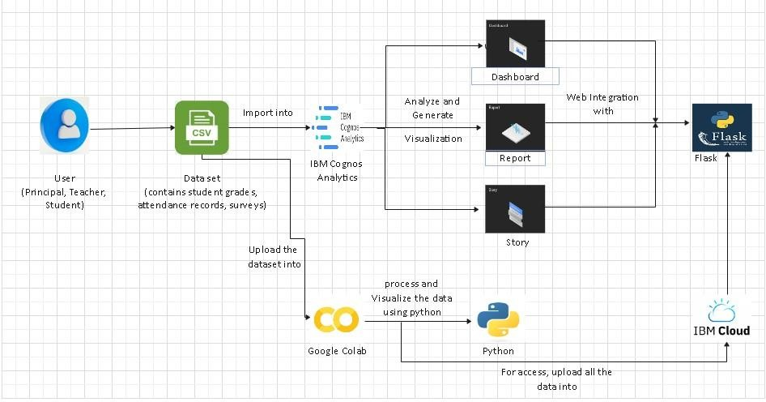

# CHAPTER-4

# REQUIREMENT ANALYSIS

**4.1 FUNCTIONAL REQUIREMENTS**

Following are the functional requirements of the proposed solution.

|  |  |  |
| --- | --- | --- |
| **FR**  **No.** | **Functional Requirement (Epic)** | **Sub Requirement (Story / Sub-Task)** |
| FR-1 | User Registration | Registration through Form Registration through Gmail  Registration through Linked-in |
| FR-2 | User Confirmation | Confirmation via Email Confirmation via OTP |
| FR-3 | Login | The user should login to the system by using valid user credentials |
| FR-4 | Dataset | Upload dataset into the analytics tool. |
| FR-5 | Analysis | It involves gathering all the information, processing it. exploring the data, and using  it to find patterns and other insights. |
| FR-6 | Create Dashboard | Create Charts, Graphs, Tables, etc. |
| FR-7 | Reporting | The reporting function helps users have complete control over their business. The real-time reporting collects current information and displays. |

## 

## 4.2 NON-FUNCTIONAL REQUIREMENTS

Following are the non-functional requirements of the proposed solution.

|  |  |  |
| --- | --- | --- |
| **FR**  **No.** | **Non-Functional Requirement** | **Description** |
| NFR-1 | **Usability** | Optimized resources and it can be used by everyone |
| NFR-2 | **Security** | Anyone with correct Log in credentials can view the Dashboards/Templates |
| NFR-3 | **Reliability** | Templates are reliable because we are uploading and accessing it through Cloud |
| NFR-4 | **Performance** | It has high state of performance and efficiency |
| NFR-5 | **Availability** | It is free of cost and available to  everyone who wants to know about sales data |
| NFR-6 | **Scalability** | Dashboards/Templates are very much Scalable, the user can modify the metrics whenever they want. |

# CHAPTER-5

# PROJECT DESIGN

**5.1 DATA FLOW DIAGRAMS**

A Data Flow Diagram (DFD) is a traditional visual representation of the information flows within a system. A neat and clear DFD can depict the right amount of the system requirement graphically. It shows how data enters and leaves the system, what changes the information, and where data is stored.

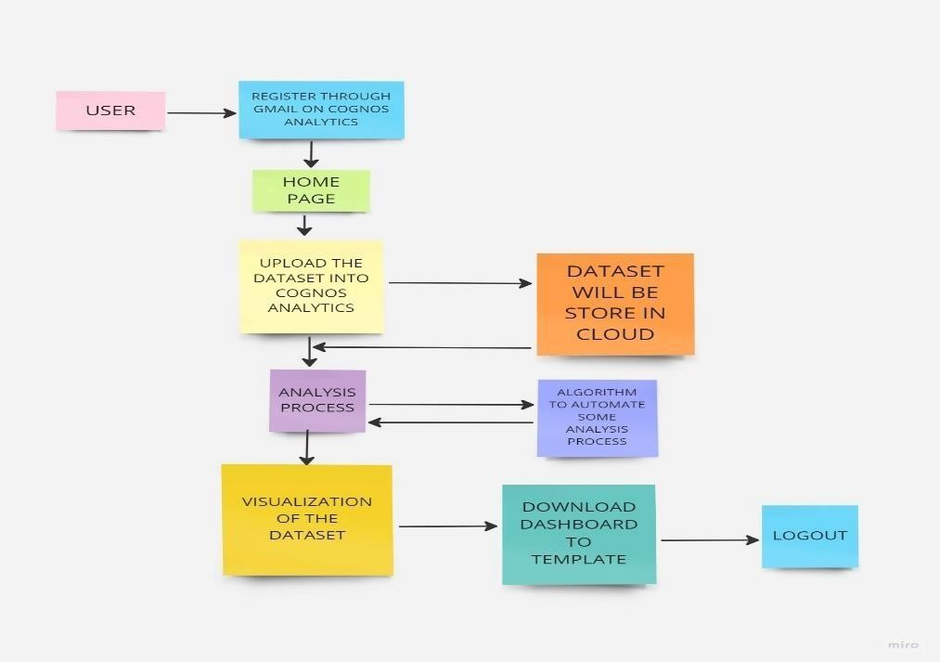

**5.2 SOLUTION AND TECHNICAL ARCHITECTURE**

**Technical Architecture:**

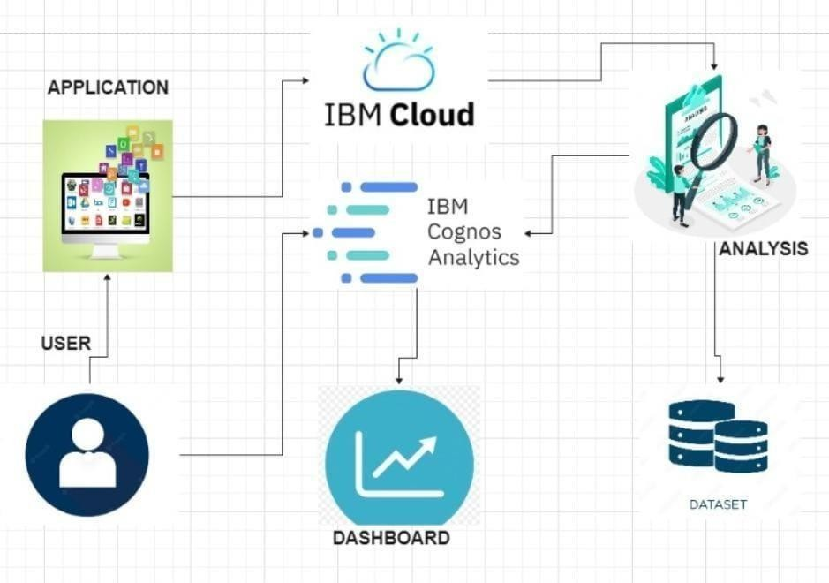

# Components & Technologies:

|  |  |  |  |
| --- | --- | --- | --- |
| **S. No** | **Component** | **Description** | **Technology** |
| 1. | User Interface | How user interacts with application | IBM Cognos Analytics |
| 2. | Working with the dataset | Cleaning, extracting process of dataset is done | IBM Cognos Analytics with Watson |
| 3. | Data Exploration | Information in the dataset is identified | IBM Cognos Analytics with Watson |
| 4. | Data Visualization | Data is represented in form of chart, table and graph in an interactive way | IBM Cognos Analytics with Watson |
| 5. | Outcome of analysis process | The user will see the visualization through  dashboards, report and story | IBM Cognos Analytics with Watson |
| 6. | Cloud Database | Uploaded data are stored in the cloud database  (Database Service on Cloud) | IBM DB2, IBM Cloud  and etc. |
| 7. | Flask | Dashboard, report, story is embedded with Flask | Cloud Flask |

# 

# Application Characteristics:

|  |  |  |  |
| --- | --- | --- | --- |
| **S. No** | **Characteristics** | **Description** | **Technology** |
| 1. | Open-Source Frameworks | List the open-source frameworks used | IBM COGNOS With  Watson, IBM CLOUD |
| 2. | Security Implementations | Secure storage and access of information | LDAP or Active Directory |
| 3. | Scalable Architecture | Supports data in different size | IBM Cloud |
| 4. | Availability | Ability to create complex, multi-page layouts using different data sources. High performance data access across all sources. Complete connectivity regardless of environment. | WebSphere  Application Server, Cognos® Business Intelligence server |
| 5. | Performance | Large amount of information can be processed | 31BM Cognos Performance  Management Hub (PMHub) |

# 5.3 USER STORIES

|  |  |  |  |  |  |  |
| --- | --- | --- | --- | --- | --- | --- |
| **User Type** | **Functional Requirement (Epic)** | **User Story Number** | **User Story / Task** | **Acceptance criteria** | **Priority** | **Team Member** |
| Customer (Web user) | Registration | USN-1 | As a user, I can register for the application by entering my email, password, and confirming  my password. | I can access my account / dashboard | High | Venkatagiriraju U |
|  |  | USN-2 | As a user, I will receive confirmation email once I  have registered for the application | I can receive confirmation  email & click confirm | High | Suryapraba V |
|  |  | USN-3 | As a user, I can register for the application through Face book | I can register & access the dashboard with Face book Login | Low | Tamizharasan K |
|  |  | USN-4 | As a user, I can register  for the application through Gmail |  | Medium | Sathiya Rubha M |
|  | Login | USN-5 | As a user, I can log into the application by  entering email & password |  | High | Suryapraba V |
|  | Dashboard | USN-6 | User can able to see and upload dataset option in the browser | The user can upload data set in Cognos  analytics | High | Venkatagiriraju U |
|  | Dashboard | USN-7 | If the user already used the Cognos analytics, we can able to see the previously uploaded  dataset |  | Low | Tamizharasan K |
| Admin | Login | USN-8 | As an admin, I can login to the application by  entering username & password |  | High | Sathiya Rubha M |
|  | Dashboard | USN-9 | As an admin, I can view the dashboard and other activities of the application. | I can access the dashboards | High | Tamizharasan K |

# CHAPTER-6

# CODING & SOLUTIONING

# INDEX.HTML:

<!DOCTYPE html>

<html lang="en">

<head>

<meta charset="utf-8">

<meta content="width=device-width, initial-scale=1.0" name="viewport">

<title>Welcome</title>

<meta content="" name="description">

<meta content="" name="keywords">

<!-- Favicons -->

<link href="assets/img/favicon.png" rel="icon">

<link href="assets/img/apple-touch-icon.png" rel="apple-touch-icon">

<!-- Google Fonts -->

<link href="https://fonts.googleapis.com/css?family=Open+Sans:300,300i,400,400i,600,600i,700,700i|Raleway:300,300i,400,400i,500,500i,600,600i,700,700i|Poppins:300,300i,400,400i,500,500i,600,600i,700,700i" rel="stylesheet">

<!-- Vendor CSS Files -->

<link href="assets/vendor/aos/aos.css" rel="stylesheet">

<link href="assets/vendor/bootstrap/css/bootstrap.min.css" rel="stylesheet">

<link href="assets/vendor/bootstrap-icons/bootstrap-icons.css" rel="stylesheet">

<link href="assets/vendor/boxicons/css/boxicons.min.css" rel="stylesheet">

<link href="assets/vendor/glightbox/css/glightbox.min.css" rel="stylesheet">

<link href="assets/vendor/remixicon/remixicon.css" rel="stylesheet">

<link href="assets/vendor/swiper/swiper-bundle.min.css" rel="stylesheet">

<!-- Template Main CSS File -->

<link href="assets/css/style.css" rel="stylesheet">

<!-- =======================================================

* Template Name: Vesperr

* Updated: Mar 10 2023 with Bootstrap v5.2.3

* Template URL: https://bootstrapmade.com/vesperr-free-bootstrap-template/

* Author: BootstrapMade.com

* License: https://bootstrapmade.com/license/

======================================================== -->

</head>

<body>

<!-- ======= Header ======= -->

<header id="header" class="fixed-top d-flex align-items-center">

<div class="container d-flex align-items-center justify-content-between">

<div class="logo">

<h1><a href="index.html">student analysis</a></h1>

<!-- Uncomment below if you prefer to use an image logo -->

<!-- <a href="index.html"><img src="assets/img/logo.png" alt="" class="img-fluid"></a>-->

</div>

<nav id="navbar" class="navbar">

<ul>

<li><a class="nav-link scrollto active" href="#hero">Home</a></li>

<li><a class="nav-link scrollto" href="#about">About</a></li>

<li><a class="nav-link scrollto" href="#services">Dashboard</a></li>

<li><a class="nav-link scrollto " href="#portfolio">Story</a></li>

<li><a class="nav-link scrollto" href="#team">Report</a></li>

<li><a class="nav-link scrollto" href="#contact">Contact</a></li>

<li><a class="getstarted scrollto" href="#about">Get Started</a></li>

</ul>

<i class="bi bi-list mobile-nav-toggle"></i>

</nav><!-- .navbar -->

</div>

</header><!-- End Header -->

<!-- ======= Hero Section ======= -->

<section id="hero" class="d-flex align-items-center">

<div class="container">

<div class="row">

<div class="col-lg-6 pt-5 pt-lg-0 order-2 order-lg-1 d-flex flex-column justify-content-center">

<h1 data-aos="fade-up">Student academic performance analysis</h1>

<h2 data-aos="fade-up" data-aos-delay="400">Here we using IBM cognos tool for analysing student's performance</h2>

<div data-aos="fade-up" data-aos-delay="800">

<a href="#about" class="btn-get-started scrollto">Get Started</a>

</div>

</div>

<div class="col-lg-6 order-1 order-lg-2 hero-img" data-aos="fade-left" data-aos-delay="200">

<img src="assets/img/hero-img.png" class="img-fluid animated" alt="">

</div>

</div>

</div>

</section><!-- End Hero -->

<main id="main">

<!-- ======= About Us Section ======= -->

<section id="about" class="about">

<div class="container">

<div class="section-title" data-aos="fade-up">

<h2>About Us</h2>

</div>

<div class="row content">

<div class="col-lg-6" data-aos="fade-up" data-aos-delay="150">

<p>

We are Computer Science Engineering pre-final year students studying at Knowledge Institute of Technology.

</p>

<p>

We here working on a IBM and Naan Mudhalvan Project.

</p>

<ul>

<li><i class="ri-check-double-line"></i> Venkatagiriraju Udayakumar</li>

<li><i class="ri-check-double-line"></i> Suryapraba Venkatesan</li>

<li><i class="ri-check-double-line"></i> Sathyaruba M</li>

<li><i class="ri-check-double-line"></i> Tamizharasan Krishnan</li>

</ul>

</div>

</div>

</div>

</section><!-- End About Us Section -->

<!-- ======= Services Section ======= -->

<section id="services" class="services">

<div class="container">

<div class="section-title" data-aos="fade-up">

<h2>Dashboard</h2>

</div>

<div class="row">

<iframe src="https://us3.ca.analytics.ibm.com/bi/?perspective=dashboard&amp;pathRef=.my_folders%2FStudentPerformance_Dashboard&amp;closeWindowOnLastView=true&amp;ui_appbar=false&amp;ui_navbar=false&amp;shareMode=embedded&amp;action=view&amp;mode=dashboard&amp;subView=model00000188051605fc_00000000" width="1200" height="800" frameborder="0" gesture="media" allow="encrypted-media" allowfullscreen=""></iframe>

</div>

</div>

</section><!-- End Services Section -->

<!-- ======= Portfolio Section ======= -->

<section id="portfolio" class="portfolio">

<div class="container">

<div class="section-title" data-aos="fade-up">

<h2>Story</h2>

</div>

<div >

<iframe src="https://us3.ca.analytics.ibm.com/bi/?perspective=story&amp;pathRef=.my_folders%2FStudent%2BPerformance%2BStory&amp;closeWindowOnLastView=true&amp;ui_appbar=false&amp;ui_navbar=false&amp;shareMode=embedded&amp;action=view&amp;sceneId=model00000188085dad69_00000001&amp;sceneTime=5000" width="1200" height="800" frameborder="0" gesture="media" allow="encrypted-media" allowfullscreen=""></iframe>

</div>

</div>

</section><!-- End Portfolio Section -->

<!-- ======= Team Section ======= -->

<section id="team" class="team section-bg">

<div class="container">

<div class="section-title" data-aos="fade-up">

<h2>Report</h2>

</div>

<div class="row">

<iframe src="https://us3.ca.analytics.ibm.com/bi/?pathRef=.my_folders%2FStudents%2BPerformance%2BReport&amp;closeWindowOnLastView=true&amp;ui_appbar=false&amp;ui_navbar=false&amp;shareMode=embedded&amp;action=edit" width="1200" height="800" frameborder="0" gesture="media" allow="encrypted-media" allowfullscreen=""></iframe>

</div>

</div>

</section><!-- End Team Section -->

<!-- ======= Contact Section ======= -->

<section id="contact" class="contact">

<div class="container">

<div class="section-title" data-aos="fade-up">

<h2>Contact Us</h2>

</div>

<div class="row">

<div class="col-lg-4 col-md-6" data-aos="fade-up" data-aos-delay="100">

<div class="contact-about">

<h3>SAMOSA TEAM</h3>

<p>We here working on a data analytics project for analysing the student performance based on their academics activities.</p>

<div class="social-links">

<a href="#" class="twitter"><i class="bi bi-twitter"></i></a>

<a href="#" class="facebook"><i class="bi bi-facebook"></i></a>

<a href="#" class="instagram"><i class="bi bi-instagram"></i></a>

<a href="#" class="linkedin"><i class="bi bi-linkedin"></i></a>

</div>

</div>

</div>

<div class="col-lg-3 col-md-6 mt-4 mt-md-0" data-aos="fade-up" data-aos-delay="200">

<div class="info">

<div>

<i class="ri-map-pin-line"></i>

<p>Knowledge Institute Of Technology<br>Salem, TN-637504</p>

</div>

<div>

<i class="ri-mail-send-line"></i>

<p>2k20cse191@kiot.ac.in</p>

</div>

<div>

<i class="ri-phone-line"></i>

<p>+91 9344907558</p>

</div>

</div>

</div>

<div class="col-lg-5 col-md-12" data-aos="fade-up" data-aos-delay="300">

<form action="forms/contact.php" method="post" role="form" class="php-email-form">

<div class="form-group">

<input type="text" name="name" class="form-control" id="name" placeholder="Your Name" required>

</div>

<div class="form-group">

<input type="email" class="form-control" name="email" id="email" placeholder="Your Email" required>

</div>

<div class="form-group">

<input type="text" class="form-control" name="subject" id="subject" placeholder="Subject" required>

</div>

<div class="form-group">

<textarea class="form-control" name="message" rows="5" placeholder="Message" required></textarea>

</div>

<div class="my-3">

<div class="loading">Loading</div>

<div class="error-message"></div>

<div class="sent-message">Your message has been sent. Thank you!</div>

</div>

<div class="text-center"><button type="submit">Send Message</button></div>

</form>

</div>

</div>

</div>

</section><!-- End Contact Section -->

</main><!-- End #main -->

<!-- ======= Footer ======= -->

<footer id="footer">

<div class="container">

<div class="row d-flex align-items-center">

<div class="col-lg-6 text-lg-left text-center">

<div class="copyright">

&copy; Copyright <strong>SAMOSA TEAM</strong>. All Rights Reserved

</div>

<div class="col-lg-6">

<nav class="footer-links text-lg-right text-center pt-2 pt-lg-0">

<a href="#intro" class="scrollto">Home</a>

<a href="#about" class="scrollto">About</a>

<a href="#">Privacy Policy</a>

<a href="#">Terms of Use</a>

</nav>

</div>

</div>

</div>

</footer><!-- End Footer -->

<a href="#" class="back-to-top d-flex align-items-center justify-content-center"><i class="bi bi-arrow-up-short"></i></a>

<!-- Vendor JS Files -->

<script src="assets/vendor/purecounter/purecounter_vanilla.js"></script>

<script src="assets/vendor/aos/aos.js"></script>

<script src="assets/vendor/bootstrap/js/bootstrap.bundle.min.js"></script>

<script src="assets/vendor/glightbox/js/glightbox.min.js"></script>

<script src="assets/vendor/isotope-layout/isotope.pkgd.min.js"></script>

<script src="assets/vendor/swiper/swiper-bundle.min.js"></script>

<script src="assets/vendor/php-email-form/validate.js"></script>

<!-- Template Main JS File -->

<script src="assets/js/main.js"></script>

</body>

</html>

**CHAPTER-7**

**RESULTS**

**7.1 PERFORMANCE METRICS**

# from flask import Flask, render_template

# app = Flask(_name_, static_url_path='/static')

# @app.route("/")

# def home():

# return render_template("index.html")

# if _name=="main_":

# app.run()

# 

# 

# 

# 

# CHAPTER-8

# ADVANTAGES & DISADVANTAGES

**Advantages:**

* Comprehensive data analysis from multiple sources (grades, test scores, attendance, surveys).
* Tailored instruction and intervention recommendations based on individual student analysis.
* Data-driven decision-making for curriculum design, instructional strategies, and resource allocation.
* Early identification of struggling students for timely intervention.
* Efficient resource allocation by targeting areas or students in need of support.

**Disadvantages:**

* Dependence on data quality and accuracy.
* Privacy and security concerns with student data.
* Potential overemphasis on quantitative data, overlooking qualitative factors.
* Resource and infrastructure requirements for implementation.
* Challenges in adoption and training for educators and administrators.

# 

# CHAPTER-9

# CONCLUSION

In conclusion, the "Student Performance Analysis and Improvement Recommendations" project is a data-driven approach to improving academic performance that uses IBM Cognos to collect and analyze data from various sources, including grades, test scores attendance records, and surveys. The project provides tailored instruction and intervention recommendations to improve student performance by identifying areas or strength and weakness and factors contributing to success or challenges.

The expected outcomes include insights into student performance, identification of areas for improvement, and recommendations for enhancing academic performance. The project underscores the importance of student performance analysis as a critical component of improving academic outcomes, and IBM Cognos as a powerful tool to achieve these goals. Ultimately, this project demonstrates the power of data-driven analysis to drive improvements in academic performance.

# CHAPTER-10

# FUTURE SCOPE

# Future enhancements to student performance analysis could include:

# Personalized Learning: Tailoring recommendations and interventions based on individual needs and learning styles.

# Predictive Analytics: Identifying early indicators of academic challenges or success to provide proactive support.

# Emotional Intelligence Monitoring: Assessing emotional states, stress levels, and engagement during learning activities to optimize motivation and engagement.

# Integration of Multiple Data Sources: Combining diverse data sets, such as academic records, test scores, attendance, and extracurricular activities, for a comprehensive understanding of student progress.

# These enhancements leverage advanced algorithms, big data, and emerging technologies to provide more accurate and insightful assessments of student performance.

# CHAPTER-11

# APPENDIX

# 11.1 SOURCE CODE

# Index.html

<!DOCTYPE html>

<html lang="en">

<head>

<meta charset="utf-8">

<meta content="width=device-width, initial-scale=1.0" name="viewport">

<title>Welcome</title>

<meta content="" name="description">

<meta content="" name="keywords">

<!-- Favicons -->

<link href="assets/img/favicon.png" rel="icon">

<link href="assets/img/apple-touch-icon.png" rel="apple-touch-icon">

<!-- Google Fonts -->

<link href="https://fonts.googleapis.com/css?family=Open+Sans:300,300i,400,400i,600,600i,700,700i|Raleway:300,300i,400,400i,500,500i,600,600i,700,700i|Poppins:300,300i,400,400i,500,500i,600,600i,700,700i" rel="stylesheet">

<!-- Vendor CSS Files -->

<link href="assets/vendor/aos/aos.css" rel="stylesheet">

<link href="assets/vendor/bootstrap/css/bootstrap.min.css" rel="stylesheet">

<link href="assets/vendor/bootstrap-icons/bootstrap-icons.css" rel="stylesheet">

<link href="assets/vendor/boxicons/css/boxicons.min.css" rel="stylesheet">

<link href="assets/vendor/glightbox/css/glightbox.min.css" rel="stylesheet">

<link href="assets/vendor/remixicon/remixicon.css" rel="stylesheet">

<link href="assets/vendor/swiper/swiper-bundle.min.css" rel="stylesheet"

<!-- Template Main CSS File -->

<link href="assets/css/style.css" rel="stylesheet">

<!-- =======================================================

* Template Name: Vesperr

* Updated: Mar 10 2023 with Bootstrap v5.2.3

* Template URL: https://bootstrapmade.com/vesperr-free-bootstrap-template/

* Author: BootstrapMade.com

* License: https://bootstrapmade.com/license/

======================================================== -->

</head>

<body>

<!-- ======= Header ======= -->

<header id="header" class="fixed-top d-flex align-items-center">

<div class="container d-flex align-items-center justify-content-between">

<div class="logo">

<h1><a href="index.html">student analysis</a></h1>

<!-- Uncomment below if you prefer to use an image logo -->

<!-- <a href="index.html"><img src="assets/img/logo.png" alt="" class="img-fluid"></a>-->

</div>

<nav id="navbar" class="navbar">

<ul>

<li><a class="nav-link scrollto active" href="#hero">Home</a></li>

<li><a class="nav-link scrollto" href="#about">About</a></li>

<li><a class="nav-link scrollto" href="#services">Dashboard</a></li>

<li><a class="nav-link scrollto " href="#portfolio">Story</a></li>

<li><a class="nav-link scrollto" href="#team">Report</a></li>

<li><a class="nav-link scrollto" href="#contact">Contact</a></li>

<li><a class="getstarted scrollto" href="#about">Get Started</a></li>

</ul>

<i class="bi bi-list mobile-nav-toggle"></i>

</nav><!-- .navbar -->

</div>

</header><!-- End Header -->

<!-- ======= Hero Section ======= -->

<section id="hero" class="d-flex align-items-center">

<div class="container">

<div class="row">

<div class="col-lg-6 pt-5 pt-lg-0 order-2 order-lg-1 d-flex flex-column justify-content-center">

<h1 data-aos="fade-up">Student academic performance analysis</h1>

<h2 data-aos="fade-up" data-aos-delay="400">Here we using IBM cognos tool for analysing student's performance</h2>

<div data-aos="fade-up" data-aos-delay="800">

<a href="#about" class="btn-get-started scrollto">Get Started</a>

</div>

</div>

<div class="col-lg-6 order-1 order-lg-2 hero-img" data-aos="fade-left" data-aos-delay="200">

<img src="assets/img/hero-img.png" class="img-fluid animated" alt="">

</div>

</div>

</div>

</section><!-- End Hero -->

<main id="main">

<!-- ======= About Us Section ======= -->

<section id="about" class="about">

<div class="container">

<div class="section-title" data-aos="fade-up">

<h2>About Us</h2>

</div>

<div class="row content">

<div class="col-lg-6" data-aos="fade-up" data-aos-delay="150">

<p>

We are Computer Science Engineering pre-final year students studying at Knowledge Institute of Technology.

</p>

<p>

We here working on a IBM and Naan Mudhalvan Project.

</p>

<ul>

<li><i class="ri-check-double-line"></i> Venkatagiriraju Udayakumar</li>

<li><i class="ri-check-double-line"></i> Suryapraba Venkatesan</li>

<li><i class="ri-check-double-line"></i> Sathyaruba M</li>

<li><i class="ri-check-double-line"></i> Tamizharasan Krishnan</li>

</ul>

</div>

</div>

</div>

</section><!-- End About Us Section -->

<!-- ======= Services Section ======= -->

<section id="services" class="services">

<div class="container">

<div class="section-title" data-aos="fade-up">

<h2>Dashboard</h>

</div>

<div class="row">

<iframe src="https://us3.ca.analytics.ibm.com/bi/?perspective=dashboard&amp;pathRef=.my_folders%2FStudentPerformance_Dashboard&amp;closeWindowOnLastView=true&amp;ui_appbar=false&amp;ui_navbar=false&amp;shareMode=embedded&amp;action=view&amp;mode=dashboard&amp;subView=model00000188051605fc_00000000" width="1200" height="800" frameborder="0" gesture="media" allow="encrypted-media" allowfullscreen=""></iframe>

</div>

</div>

</section><!-- End Services Section -->

<!-- ======= Portfolio Section ======= -->

<section id="portfolio" class="portfolio">

<div class="container">

<div class="section-title" data-aos="fade-up">

<h2>Story</h2>

</div>

<div >

<iframe src="https://us3.ca.analytics.ibm.com/bi/?perspective=story&amp;pathRef=.my_folders%2FStudent%2BPerformance%2BStory&amp;closeWindowOnLastView=true&amp;ui_appbar=false&amp;ui_navbar=false&amp;shareMode=embedded&amp;action=view&amp;sceneId=model00000188085dad69_00000001&amp;sceneTime=5000" width="1200" height="800" frameborder="0" gesture="media" allow="encrypted-media" allowfullscreen=""></iframe>

</div>

</div>

</section><!-- End Portfolio Section -->

<!-- ======= Team Section ======= -->

<section id="team" class="team section-bg">

<div class="container">

<div class="section-title" data-aos="fade-up">

<h2>Report</h2>

</div>

<div class="row">

<iframe src="https://us3.ca.analytics.ibm.com/bi/?pathRef=.my_folders%2FStudents%2BPerformance%2BReport&amp;closeWindowOnLastView=true&amp;ui_appbar=false&amp;ui_navbar=false&amp;shareMode=embedded&amp;action=edit" width="1200" height="800" frameborder="0" gesture="media" allow="encrypted-media" allowfullscreen=""></iframe>

</div>

</div>

</section><!-- End Team Section -->

<!-- ======= Contact Section ======= -->

<section id="contact" class="contact">

<div class="container">

<div class="section-title" data-aos="fade-up">

<h2>Contact Us</h2>

</div>

<div class="row">

<div class="col-lg-4 col-md-6" data-aos="fade-up" data-aos-delay="100">

<div class="contact-about">

<h3>SAMOSA TEAM</h3>

<p>We here working on a data analytics project for analysing the student performance based on their academics activities.</p>

<div class="social-links">

<a href="#" class="twitter"><i class="bi bi-twitter"></i></a>

<a href="#" class="facebook"><i class="bi bi-facebook"></i></a>

<a href="#" class="instagram"><i class="bi bi-instagram"></i></a>

<a href="#" class="linkedin"><i class="bi bi-linkedin"></i></a>

</div>

</div>

</div>

<div class="col-lg-3 col-md-6 mt-4 mt-md-0" data-aos="fade-up" data-aos-delay="200">

<div class="info">

<div>

<i class="ri-map-pin-line"></i>

<p>Knowledge Institute Of Technology<br>Salem, TN-637504</p>

</div>

<div>

<i class="ri-mail-send-line"></i>

<p>2k20cse191@kiot.ac.in</p>

</div>

<div>

<i class="ri-phone-line"></i>

<p>+91 9344907558</p>

</div>

</div>

</div>

<div class="col-lg-5 col-md-12" data-aos="fade-up" data-aos-delay="300">

<form action="forms/contact.php" method="post" role="form" class="php-email-form">

<div class="form-group">

<input type="text" name="name" class="form-control" id="name" placeholder="Your Name" required>

</div>

<div class="form-group">

<input type="email" class="form-control" name="email" id="email" placeholder="Your Email" required>

</div>

<div class="form-group">

<input type="text" class="form-control" name="subject" id="subject" placeholder="Subject" required>

</div>

<div class="form-group">

<textarea class="form-control" name="message" rows="5" placeholder="Message" required></textarea>

</div>

<div class="my-3">

<div class="loading">Loading</div>

<div class="error-message"></div>

<div class="sent-message">Your message has been sent. Thank you!</div>

</div>

<div class="text-center"><button type="submit">Send Message</button></div>

</form>

</div>

</div>

</div>

</section><!-- End Contact Section -->

</main><!-- End #main -->

<!-- ======= Footer ======= -->

<footer id="footer">

<div class="container">

<div class="row d-flex align-items-center">

<div class="col-lg-6 text-lg-left text-center">

<div class="copyright">

&copy; Copyright <strong>SAMOSA TEAM</strong>. All Rights Reserved

</div>

<div class="col-lg-6">

<nav class="footer-links text-lg-right text-center pt-2 pt-lg-0">

<a href="#intro" class="scrollto">Home</a>

<a href="#about" class="scrollto">About</a>

<a href="#">Privacy Policy</a>

<a href="#">Terms of Use</a>

</nav>

</div>

</div>

</div>

</footer><!-- End Footer -->

<a href="#" class="back-to-top d-flex align-items-center justify-content-center"><i class="bi bi-arrow-up-short"></i></a>

<!-- Vendor JS Files -->

<script src="assets/vendor/purecounter/purecounter_vanilla.js"></script>

<script src="assets/vendor/aos/aos.js"></script>

<script src="assets/vendor/bootstrap/js/bootstrap.bundle.min.js"></script>

<script src="assets/vendor/glightbox/js/glightbox.min.js"></script>

<script src="assets/vendor/isotope-layout/isotope.pkgd.min.js"></script>

<script src="assets/vendor/swiper/swiper-bundle.min.js"></script>

<script src="assets/vendor/php-email-form/validate.js"></script>

<!-- Template Main JS File -->

<script src="assets/js/main.js"></script>

</body>

</html>

# App.py

from flask import Flask, render_template

app = Flask(_name_, static_url_path='/static')

@app.route("/")

def home():

return render_template("index.html")

if _name=="main_":

app.run()

# 11.2 SCREEN SHOTS:

**Dashboard:**

Dashboards are useful across different industries and verticals because they’re highly customizable. They can include data of all sorts with varying date ranges to help you understand: what happened, why it happened, what may happen, and what action you should take. And since dashboards use visualizations like tables, graphs, and charts, others who aren’t as close to the data can quickly and easily understand the story it tells or the insights it reveals.

Tab 1:

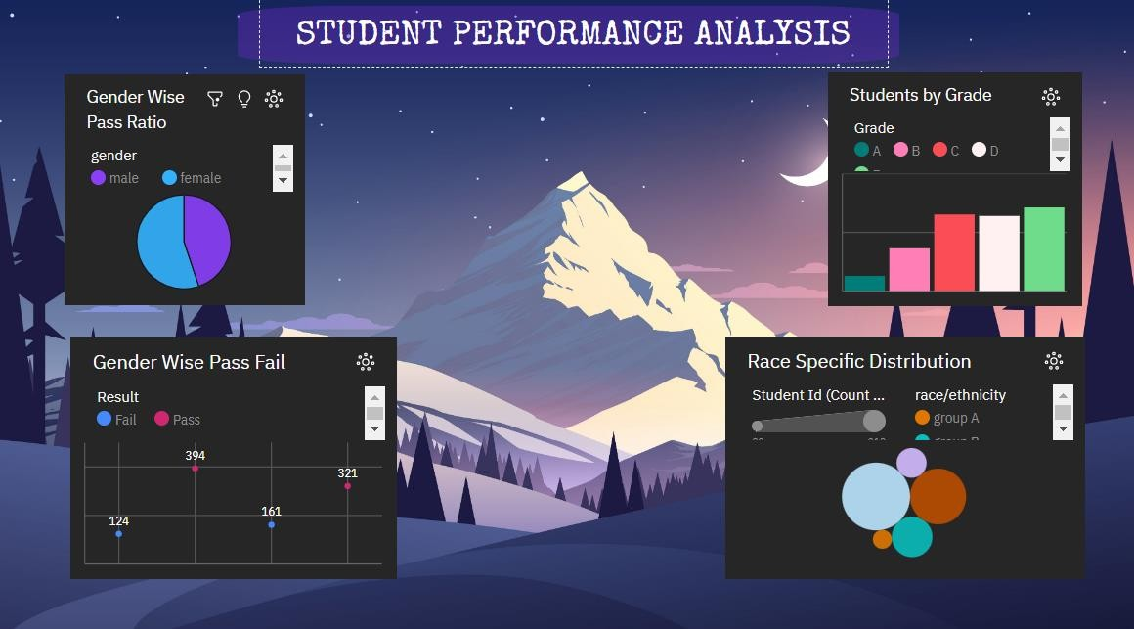

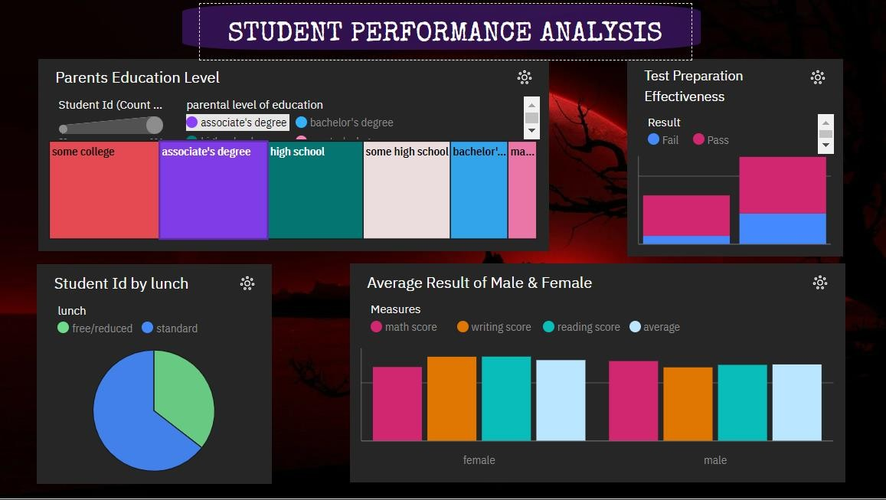Tab 2:

Tab 3:

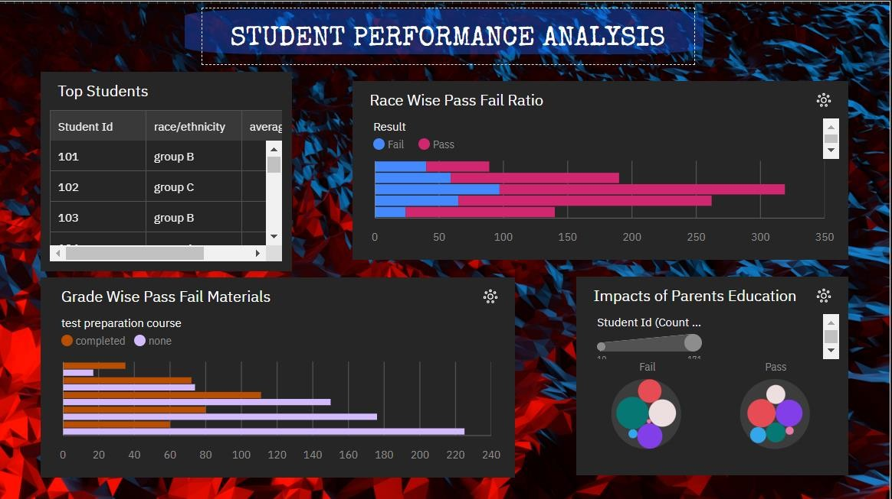

# Story:

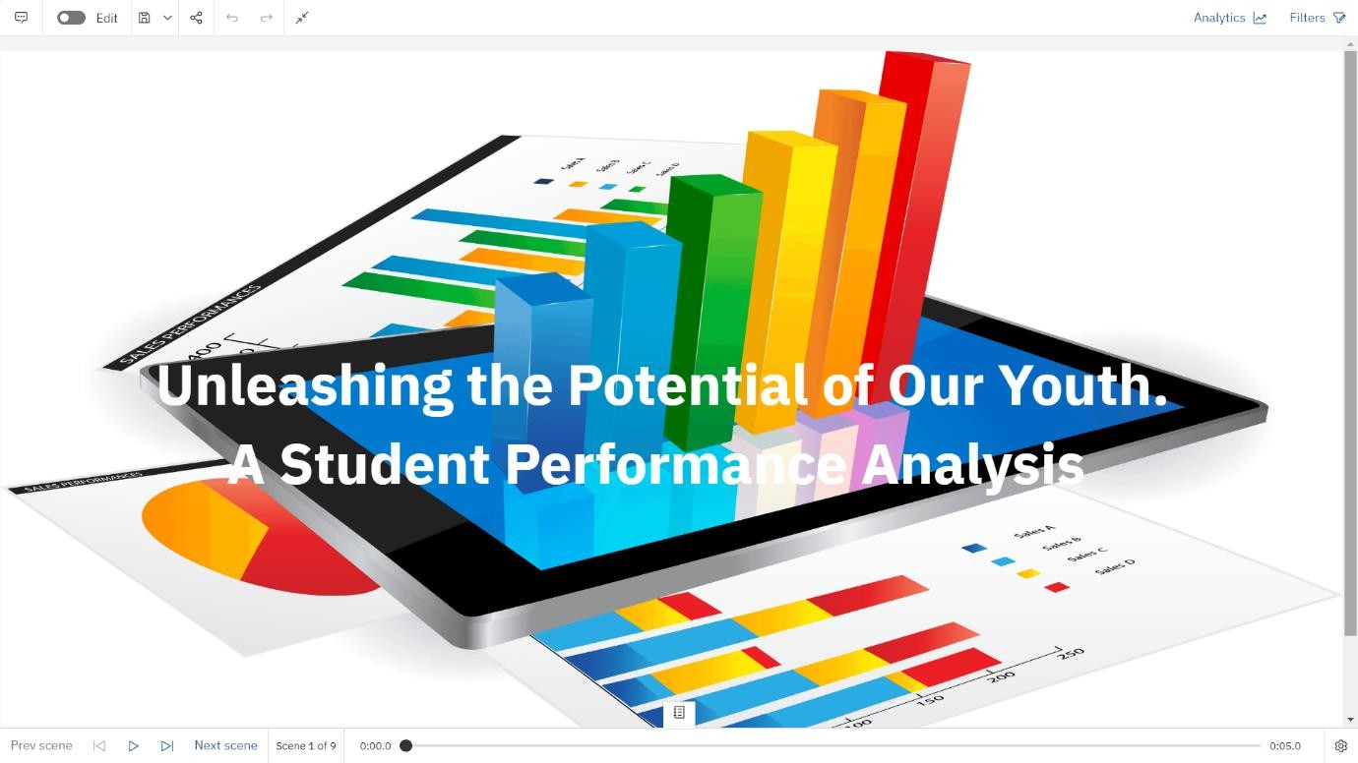

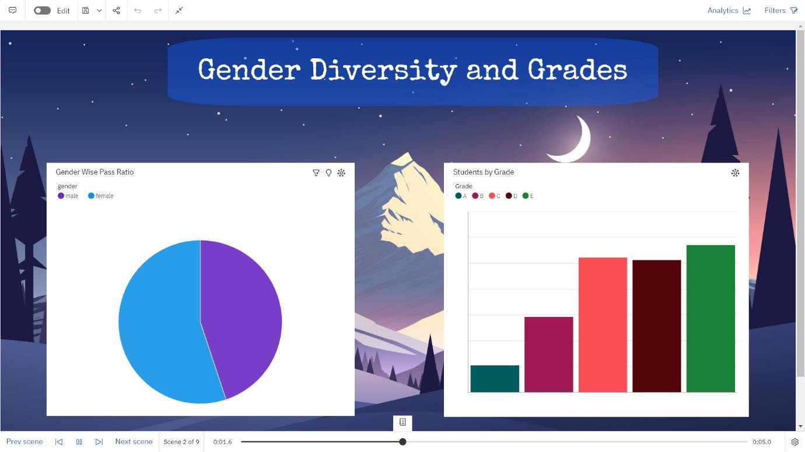

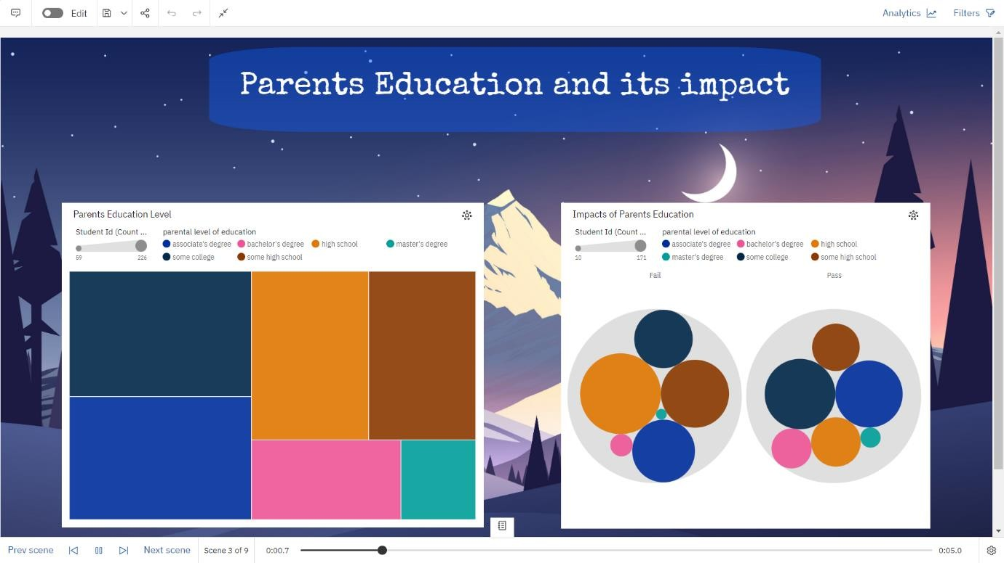

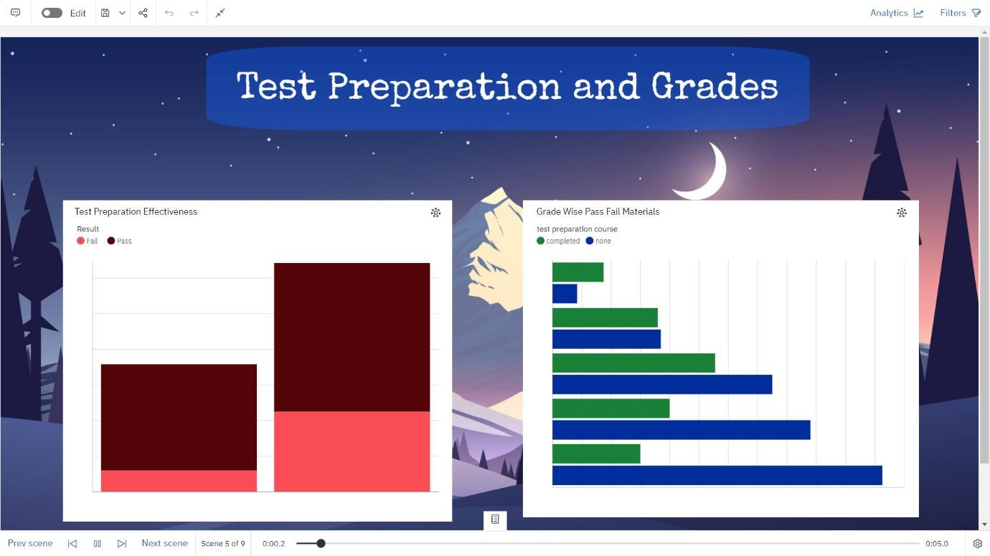

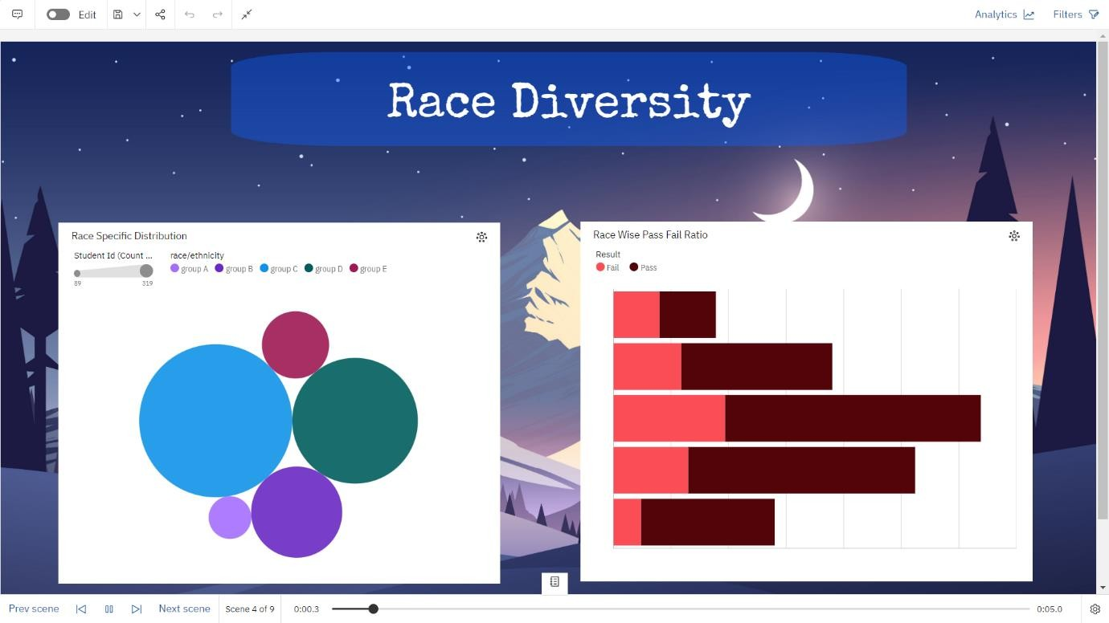



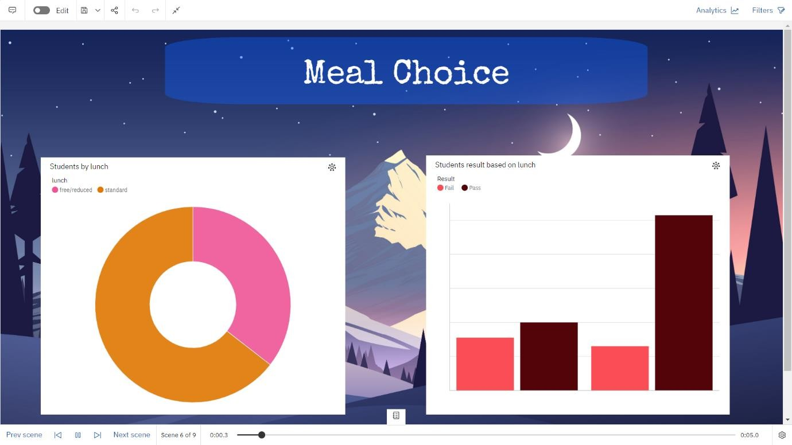

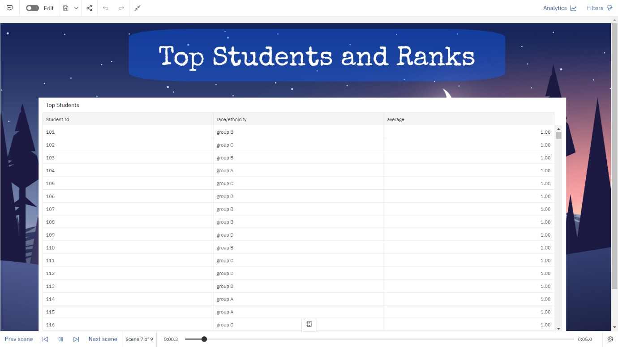

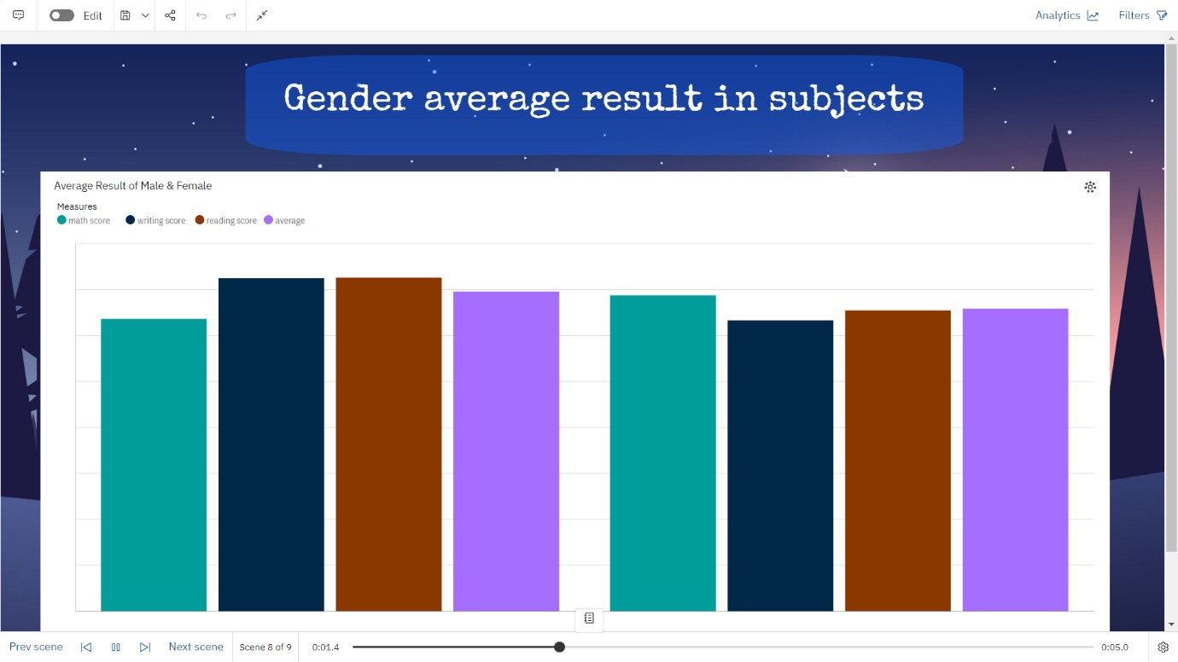

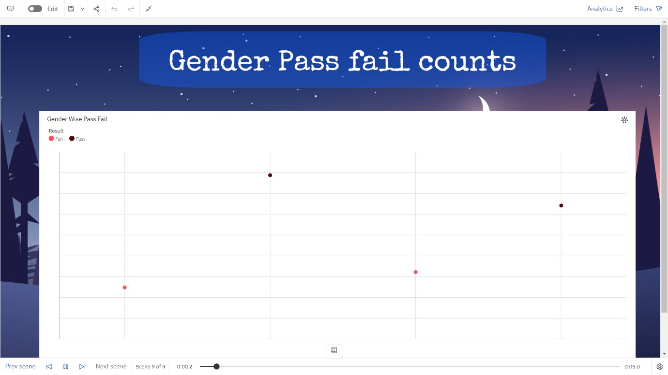

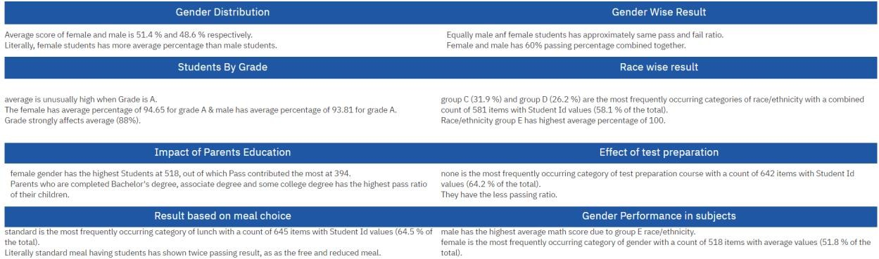 **Report:**

All the performance testing are carried for the student performance analytics.

## GITHUB & PROJECT VIDEO DEMO LINK

**GitHub -** <https://github.com/naanmudhalvan-SI/PBL-NT-GP--2845-1680631303/tree/main>

**Demo link -** https://drive.google.com/file/d/1B1MMKipWv59KT0fQZeYQ1C1XPv2uZeX5/view?usp=sharing

# REFERENCES

1. Academic Performance Analysis [Apr 2021]

Mr. M. Thirunavukkarasu, B.J.S.S Sriram, Javvaji Chandrasekhar Reddy

Website Link: <https://www.ijres.org/papers/Volume-10/Issue-6/100618041809.pdf>

Accessed Date: 29 Apr 2023

1. Student Performance Analysis System [04 Apr 2021]

Somya Mishra, Mrunal Lokare, Aniket Patil, Prof. Chandrashekhar Badgujar

Website Link: <https://www.irjet.net/archives/V8/i4/IRJET-V8I4700.pdf>

Accessed Date: 29 Apr 2023

1. Student Performance Analysis System using Data Mining [24 Apr 2020]

Disha Kalambe, Anita Labade, Surabhi Khedekar, Komal Mahajan

Website Link: [https://www.ijert.org/student-performance-analysis-system-using-data- mining](https://www.ijert.org/student-performance-analysis-system-using-data-%20%20%20%20%20%20%20mining)

Accessed Date: 29 Apr 2023

1. Students’ Performance Analysis Using Machine Learning Algorithms [29 June 2022]

Rosemary Vargheese, AdlenePeraira , Aswathy Ashok and Bassant Johnson

Website Link: <https://www.ijres.org/papers/Volume-10/Issue-6/100618041809.pdf>

Accessed Date: 29 Apr 2023

1. Student Performance Analysis System [Jan 2021]

Chew Li Sa, DayangHananibt. Abang Ibrahim, Emmy Dahliana Hossain, Mohammad bin Hossin

Website Link: <https://www.researchgate.net/publication/282956807_Student_performance_analysis_system_SPAS>

Accessed Date: 29 Apr 2023

1. Students Performance Analysis System [06 June 2020]

Vinay Devabhaktuni, Kancharla Sharath Reddy, V. Shiva Teja, G. Kavitha Reddy

Website Link: <https://www.irjmets.com/uploadedfiles/paper/issue_6_june_2022/26568/final/fin_irjmets1655801430.pdf>

Accessed Date: 29 Apr 2023

1. Students Performance Analysis System Using Cumulative Predictor Algorithm [22 May 2022]

Mr. K. Praveen Kumar, K. Sai Pranav, D Gowtham, S. Abhishek

Website Link: <https://www.ijraset.com/research-paper/students-performance-analysis-system-using-cumulative-predictor-algorithm>

Accessed Date: 29 Apr 2023

1. Student Performance Analysis System [Sep 2020]

Devita Durge, Nikhil Bagul, RushikeshGadge, Siddhesh Bhavsar

# Website Link: <https://www.jetir.org/view?paper=JETIR2009095>

Accessed Date: 29 Apr 2023

# 

# 